**IMPORTANCE OF CUSTOMER’S COMMENTS/ POSTS**

Customer feedback is one of the most reliable sources for tangible data that further can be used in taking business decisions. One must learn how to listen to it and how to translate it into actionable takeaways for the business. Customer insights will help to understand clients and their needs more profoundly.

Top performing companies understand an important role that customer feedback plays in business. They consistently listen to the voice of their clients. Not only they search for opinions they clients publish on social media and reviews they provide on websites designed for gathering feedback, but they also deliberately ask for feedback using distinct kinds of surveys. To stay ahead of competition, one should never stop listening to customer feedback whether it is positive or negative, prompted or unprompted.

**ABOUT THE DATA**

The data consists of customer’s comments/ posts on beauty products. The sheet includes categories and subcategories, as well as the number of monthly conversations on a certain brand/product/issue, and so on.

Definition of data:

1. “Number” Sheet

Keywords: count of each keyword from Jan 2020 till June 2021

Category: all keywords are bucket into different categories

Super Category: all categories are bucket into super categories

1. “Text” Sheet

It contains text data that is related to numerical data.

**GOAL**

The analysis' principal goal is to extract the most important insights from the data. In specific, we want to understand –

1. Key trends in category
2. Most important pain points or issues customers are facing
3. What drives product consideration in category and why?
4. Which brands have the strongest purchase intent out of the mix and why?

**APPROACH FOLLOWED**

* **Pivoting the data –** The data consists of separate field for each month-year from January-2020 till June-2021. In order to have a month-year field and its corresponding number of conversations in another field, data has been pivoted for ease.
* **Understanding Key Trends in Category –**

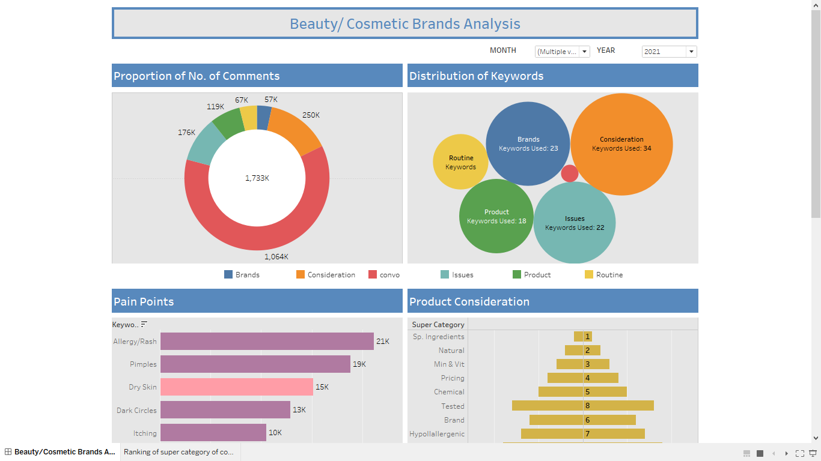

* **Customer pain points**

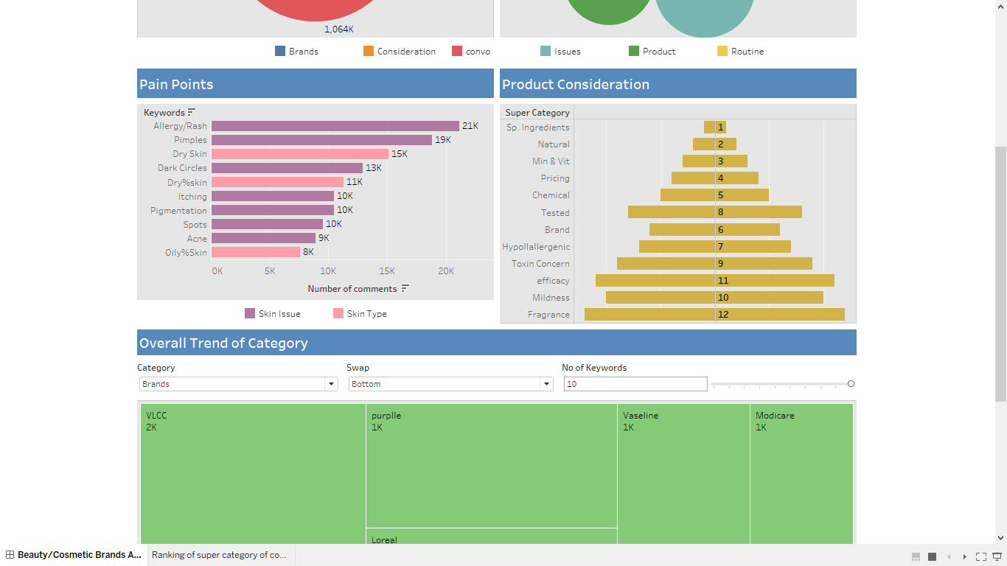

* **Product Consideration**

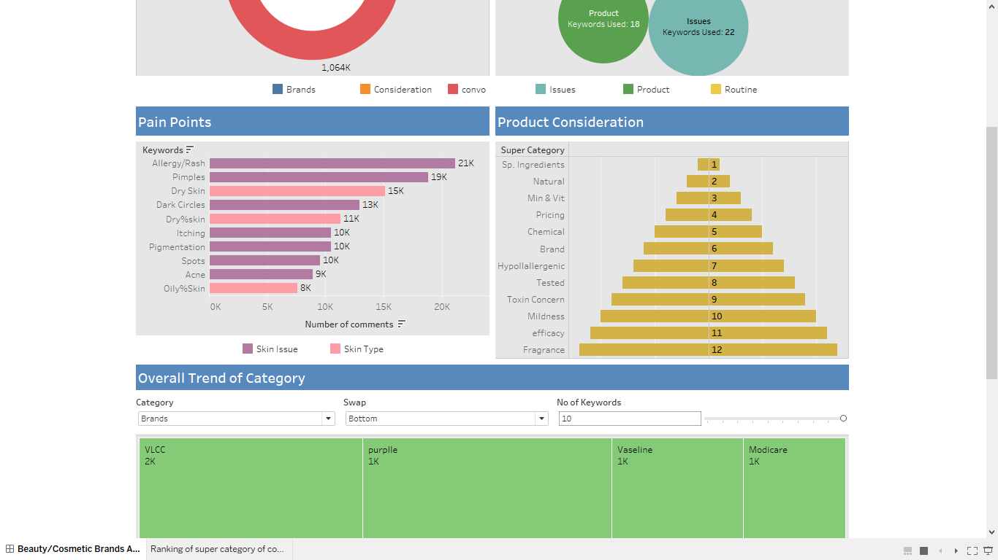

* **Overall Trend of Category, e.g., Top Brands**

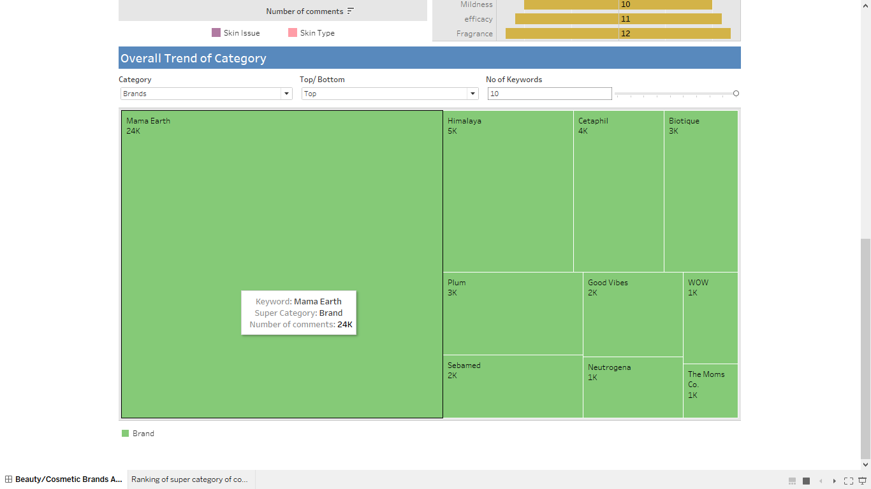

**CONCLUSION**

1. The "convo" category covers the largest portion of all the categories. After digging deeper into the data, it was discovered that it only contains one keyword, "Count," which was cited in around 1,371K comments.
2. It appears that the keywords in the Brands, Issues, Consideration, and other categories can provide a lot of information. “Mamaearth”, for example, is the most popular brand, with over 32K comments.
3. "Allergy/Rash" covers 24% of the top 10 concerns. Dry skin is the skin type of 12% of the customers.
4. Product consideration has been discovered to provide us with marketing suggestions for new or future items, such as "chamomile tea", a special ingredient that customers want the most in their beauty cosmetics.